**Logical reasoning Test (set 2)**

**Company name: Microsoft No. of Question: 10**

**1:**

If O denotes ‘Addition’, M denotes ‘Subtraction’, A denotes ‘Multiplication’, Q denotes ‘Division’, then Out of the four alternatives given in these questions, Identify the correct answer?

51 M 45 Q 9 A 8 O 2=?

1. 11
2. 13
3. 15
4. 16

**Answer:** option b

**Solution:**

51 – 45 ÷ 9 × 8 + 2 = 51 – 40 + 2 = 13

**2:**

Which of the following option can complete a given diagram?

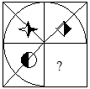

1. 
2. 
3. 
4. 

**Answer:** option d

**Solution:**

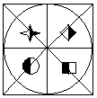

**3:**

Find the missing number?

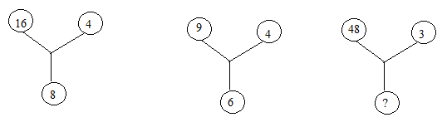

1. 11
2. 14
3. 12
4. 9

**Answer:** option c

**Solution:**

16×4 = 82

9×4 = 62

48×3 =122

**4:**

How many dots lie opposite to the face having three dots, when the given figure is folded to form a cube?

https://www.indiabix.com/_files/images/non-verbal-reasoning/cubes-and-dice/cubes/24.png

1. 2
2. 4
3. 5
4. 6

**Answer:** option d

**Solution:**

When the figure is folded to form a cube then the face bearing 6 dots will lie opposite to the face bearing 3 dots.

Also, 4 will be opposite to 5 and 1 will be opposite to 2.

Hence, 6 is the correct answer.

**5:**

In the following question, select the number which can be placed at the sign of question mark (?) from the given alternatives.

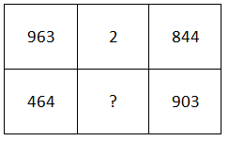

1. 10
2. 2
3. 6
4. 4

**Answer:** option b

**Solution:**

First row = (9 + 6 + 3) - (8 + 4 + 4) = 2.

Thus, second row = (4 + 6 + 4) - (9 + 0 + 3) = 2.

So, missing number = 2

**6:**

Find the word which cannot be formed using APPROPIATE?

1. TOPPER
2. ROPE
3. PROPER
4. RAGOR

**Answer:** option d

**Solution:**

Only RAGOR cannot be formed using APPROPIATE.

**7:**

Answer the following question according to the following code?

A @ B means that A is the brother of B.

A $ B means that A is the mother of B.

In M @ R $ D, How M is related to D?

1. Father
2. Mother
3. Maternal Uncle
4. Uncle

**Answer:** option c

**Solution:**

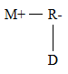

**8:**

Find the number of squares present in this following figure?

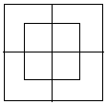

1. 8
2. 9
3. 10
4. 11

**Answer:** option c

**Solution:**

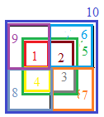

**9:**

In the row of boys, Mihir sits third to the right of Sunil, who is sitting ninth in the row from the left. Find the position of Mihir in the row from right?

1. 16
2. 15
3. 17
4. Information is incomplete

**Answer:** option d

**Solution:**

Information is incomplete

**10:**

Select an alternative from figure (a), (b), (c) and (d) which contain symbols to exactly make the problem figure (X).

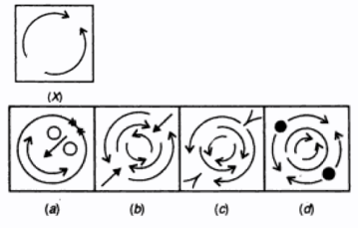

1. (a)
2. (b)
3. (c)
4. (d)

**Answer:** option c

**Solution:**

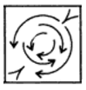

In Figure (c) head of all the curved arrows face each other.

Hence Figure (c) contains all the symbols of figure (X).